The Winter Formal Dance

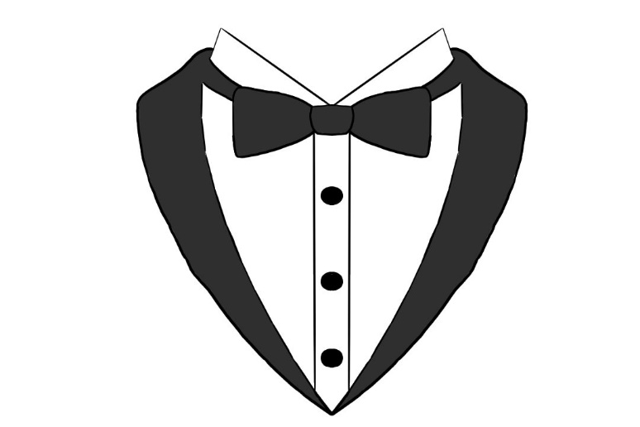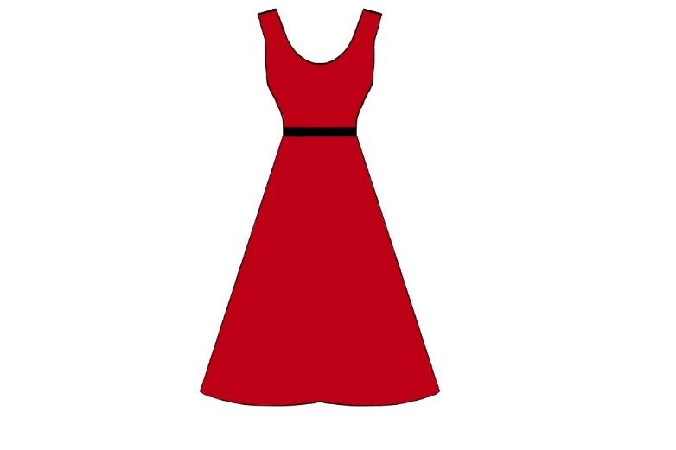

Name: ___________________

Year: ____________________

**Choose 20 words in the paragraph below and find synonyms for them.**

It is an exciting night for the students of Outspoken High! It is the winter formal dance, a fundraiser that the dance committee has put together to raise  for the less fortunate schools in the area, helping other students in need. There is an entrance fee upon arriving at the , the refreshments are to be paid for and there is a donation  for anyone who wishes to donate; there are also fun activities for everyone to participate in with big companies that are also donating to the fundraiser.

Iris, Maya and Asuka have the most beautiful and elegant 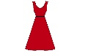 , long and flowy with amazing beadwork. The boys are looking good too with their sleek, black  and for once, neat hair! “Wow Oscar! You look so handsome, your hair is neat tonight,” Asuka says in admiration. “Thank you Asuka! You look stunning as always!” Oscar says,  at Asuka.

The  gets a bit louder and it is time for the dance competition. Everyone crowds into the centre of the room, enjoying the  and dancing with their friends. The lights are a subtle blue-white and the floor is covered with a bit of , to match the atmosphere. The music switches to a slow dance and the students choose their friends to dance with, having fun through the entire song. As the song fades out, fake  is released from massive  that are stuck to the ceiling, floating down the room and onto everyone’s heads and the floor. The students cheer and laugh, throwing handfuls of  at each other.

By the end of the night, the principle announces the amount of  that has been raised from the event. Everyone is shocked by how much the amount is, everyone has been so generous tonight and it is the perfect end to the most amazing night!